California Department of Education Monitoring Tool Agency User Manual
January 2018
Table of Contents

Logon Screen 3
Select Agency Screen 4
Home Screen/Home Tab 5
Reviews Screen/Reviews Tab 6
Review Summary Screen 7
Program Instrument Items Screen 9
Incomplete Evidence Requests Screen 10
Agency User Management Screen/Users Tab 11
Agency Documents Screen/Documents Tab 14
Posting and Viewing Comments 16
Evidence Requests Screen/Tab 18
Certify Evidence Screen/Tab 23
View Resources 25
Recent Activity Tab 27
Stages of the Review 28
Glossary 31

Logon Screen
The Centralized Authentication System (CAS) is a separate system for creating and managing user accounts. The CAS user account is used to access the California Department of Education Monitoring Tool (CMT).
To reset and/or update a user password to access CMT, the user will need to use CAS. CAS will require users to update passwords periodically.
CAS may be accessed at https://www3.cde.ca.gov/cdeauthentication/logon.aspx?programabbr=CMT
To log on to CMT, enter the user name and password and select the “Submit” button on the logon screen.
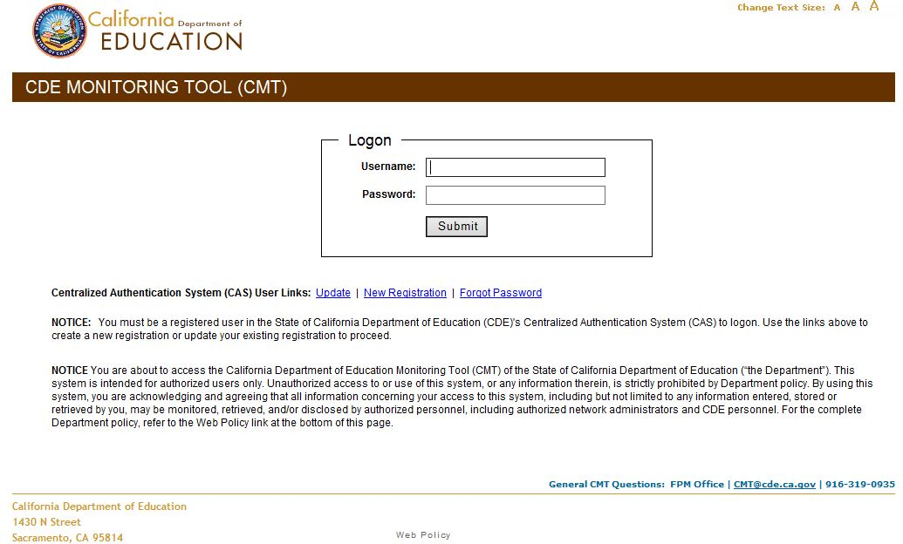

Select Agency Screen
If the user is assigned to more than one agency, use the drop-down menu to select the agency to access:
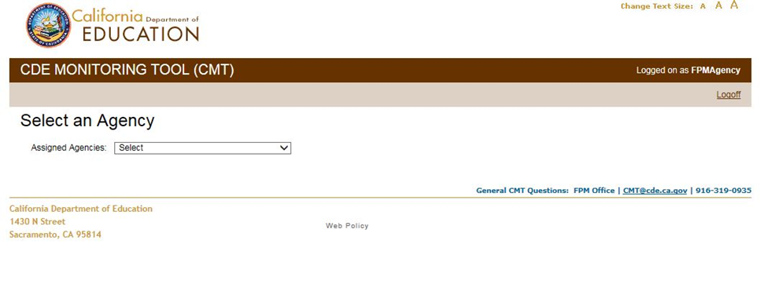
In CMT, on certain screens, there is a “Switch Agency” link in the top right corner (see below). If the user is assigned to more than one agency, the user can select this link to be directed to the “Select Agency” screen (above). The user can then choose a different agency from the drop-down menu and access that agency’s information.
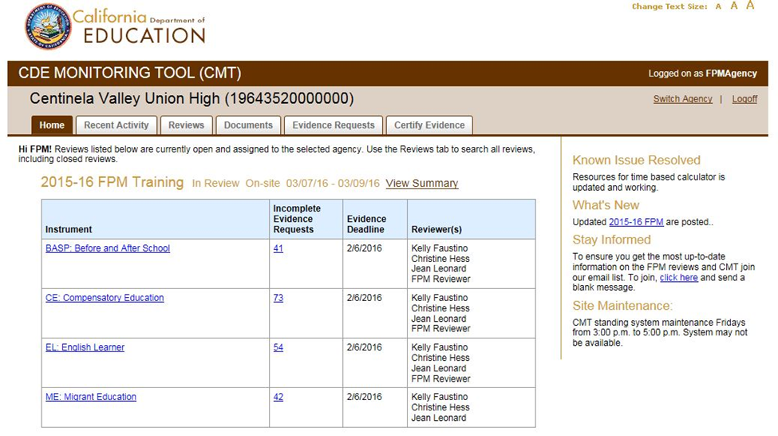

Home Screen/Home Tab
The agency “Home” screen displays reviews currently open and assigned to the selected agency. Open reviews are reviews that are in the pre-review stage, undergoing review during the review dates, or in the resolution stage with findings remaining to be resolved. If the user has more than one open review displaying on the “Home” screen, select the review title to access a particular review.
The bulletin board area to the right of the screen contains useful information and may be updated when any new useful information is available, for example information about planned system shutdown times for system maintenance.
Contact information for relevant offices appears at bottom of the screen.
For each review, there is a “View Summary” link on the “Home” screen, which will direct the user to a summary of more detailed review information on the “Review Summary” screen under the “Reviews” tab (p. 6).
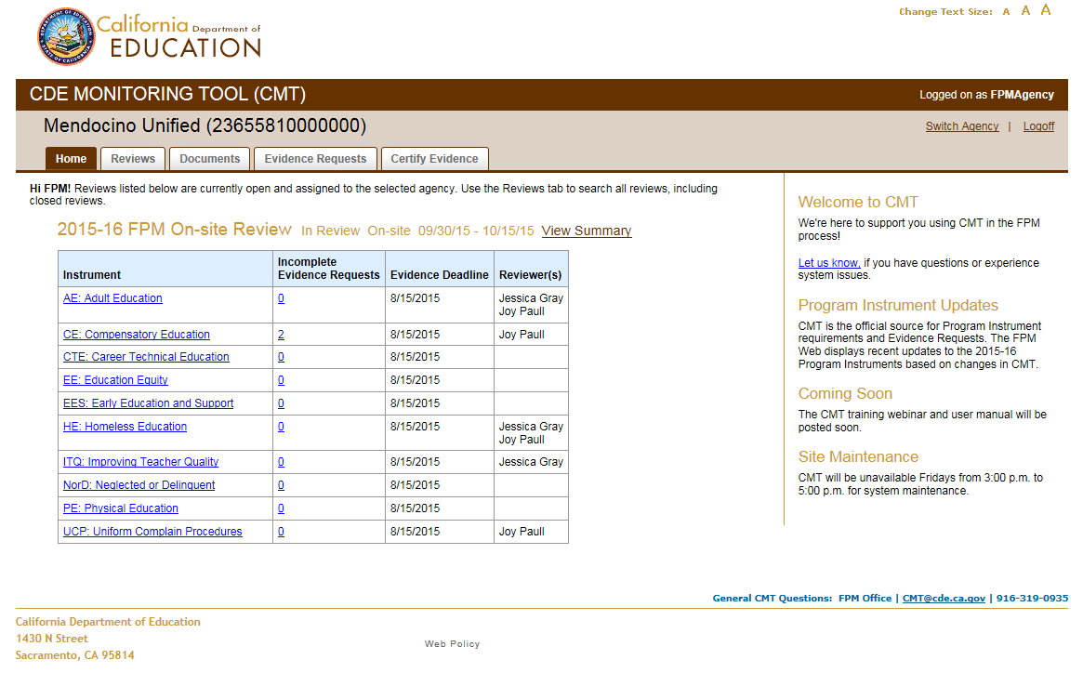
On various other CMT screens, there is a “Review Summary” link in the upper right corner which also directs the user to the “Review Summary” screen under the “Reviews” tab (see screen shot on p. 7).

Reviews Screen/Reviews Tab
All reviews are displayed here for the agency, including active (pre-review, in review, and in resolution review stages) and inactive (complete review stage) reviews.
The user can filter by review type and year using the drop-down menus, to display specific reviews on the “Reviews” screen.
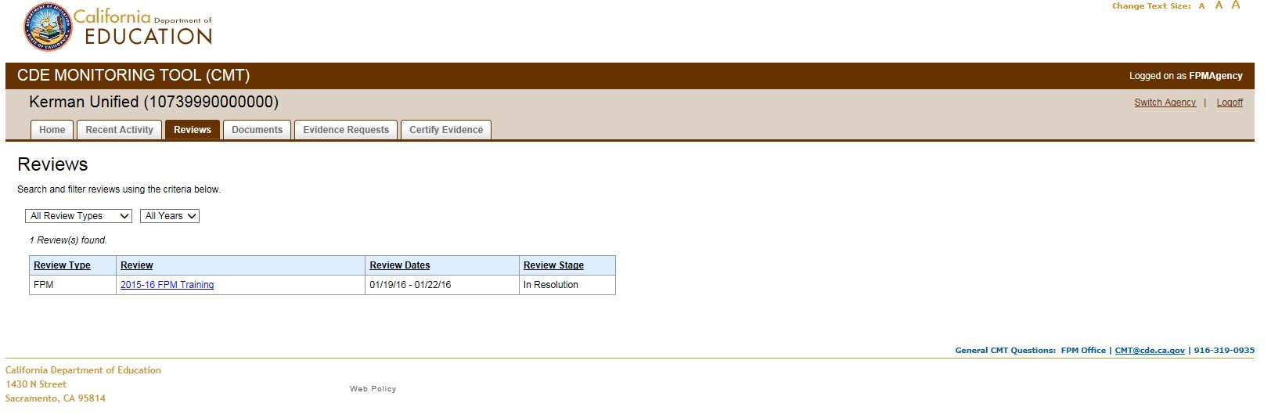
The “Reviews” screen displays for each review the review type, a link to the review summary (p. 7), the review dates, and the current review stage for each review.

Review Summary Screen
The “Review Summary” screen is reached by a user in a number of ways: (1) Selecting “View Summary” link in the “Home” tab (p. 5), (2) selecting the review link in the “Review” tab (p. 6), or (3) Selecting the “Review Summary” link displayed on many screen in CMT (p. 8).
The “Review Summary” screen includes a link to the California Department of Education (CDE) Compliance Monitoring Web page which, when selected, opens up a separate browser tab as indicated by the icon of a box and arrow next to the link. The CDE Compliance Monitoring Web page contains useful information and resources, including downloadable versions of the program instruments.
The “Review Summary” screen also contains a detailed overview of the review, including:
- Review dates
- Deadlines
- On-site details for on-site reviews
- Contact information for the Regional Team Leader(s) (RTLs) and CDE program reviewers
- Contact information for Agency Review Coordinators and program staff
- Review sites indicating which schools are being reviewed as well as which programs will be reviewed at each site
- Links to each program instrument (p. 9) and links to the incomplete evidence requests for each instrument (p. 10)
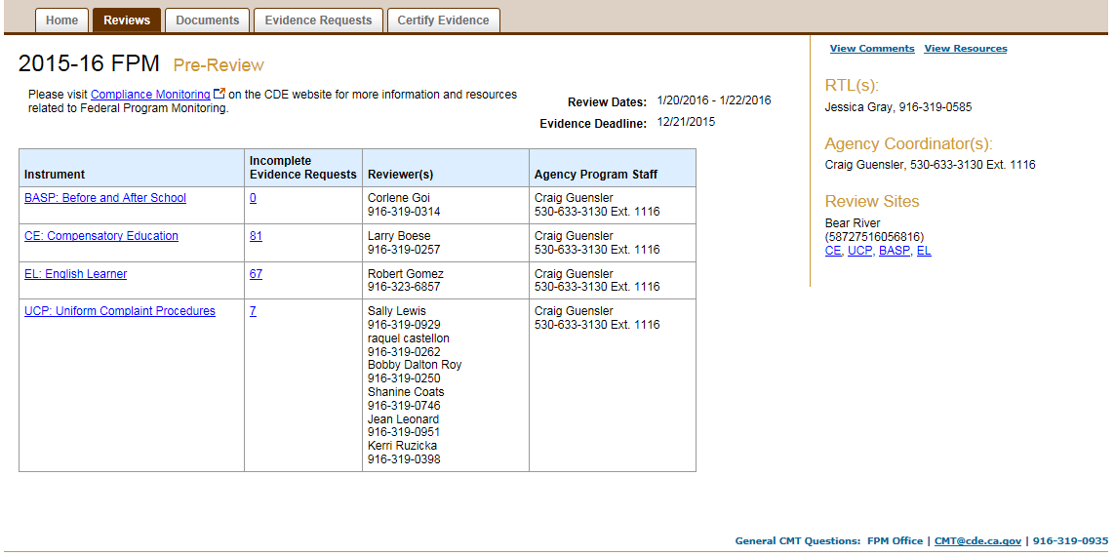
In the Resolution stage, the “Review Summary” screen will display for each instrument:
- The number of unresolved findings
- A link to the incomplete evidence requests
- The assigned CDE program reviewer(s)
- The assigned agency program staff
- The resolution deadline
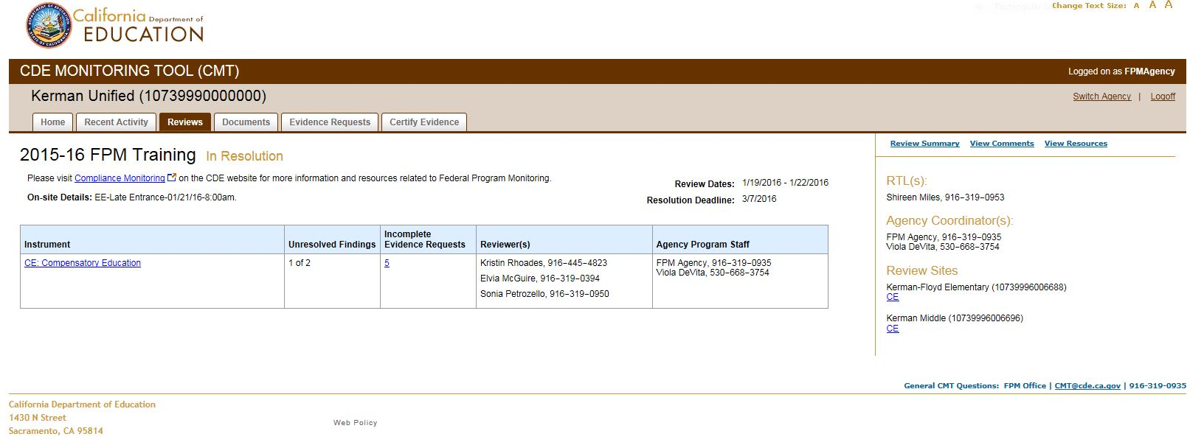

Program Instrument Items Screen
If the user selects a program instrument link, the screen will display a link for each of the instrument’s items, along with whether each item is monitored and whether further evidence is needed for each item.
On the program instrument items screen, to the right is the Comments area where the user can add a comment by typing in the text box, selecting the level of the comment from the drop-down menu, and selecting the “Add Comment” button. To view all comments pertaining to this instrument, select the “View Comments” link located above the Comments area.
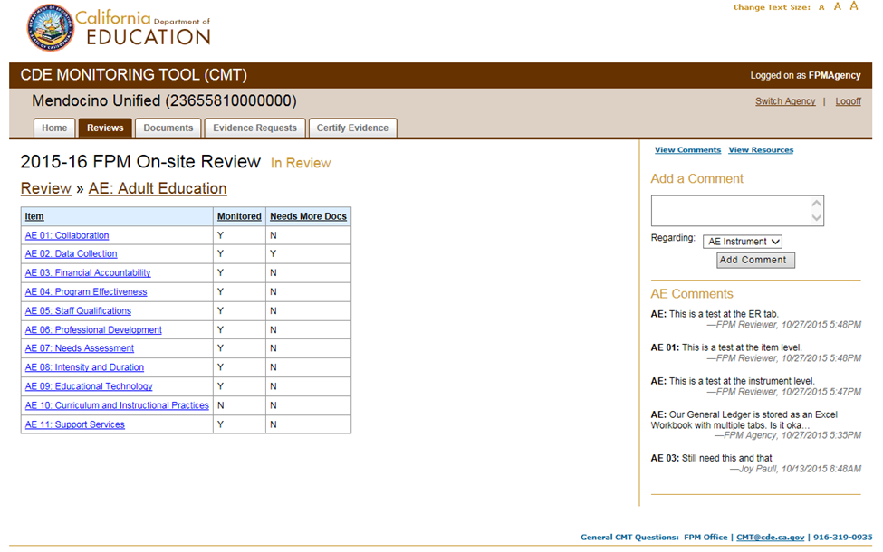
Selecting an instrument item link will display the item’s legal requirements:
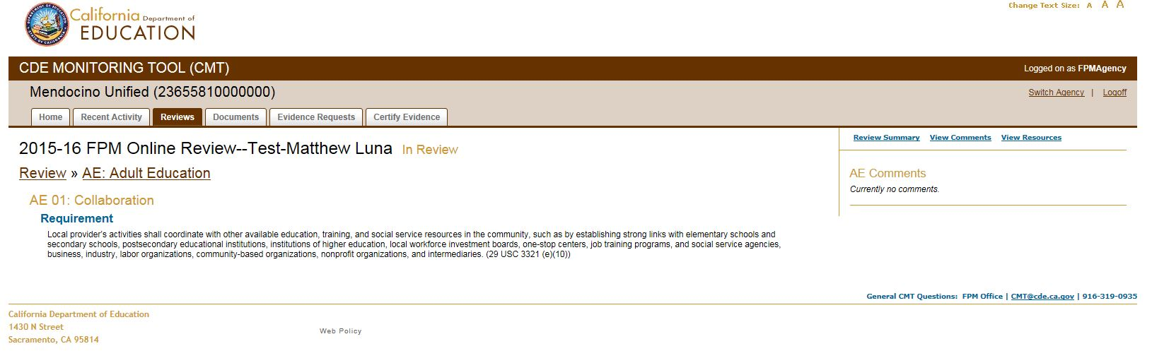

Incomplete Evidence Requests Screen
To see detail for each incomplete evidence request for a particular instrument, select the link for the number of incomplete evidence requests for that instrument from the “Review Summary” screen (p. 7). The “Evidence Requests” screen then displays:
- Each incomplete evidence request for the instrument by name
- The number of documents currently linked to each evidence request
- Whether the evidence request is required (monitored)
- The request status (“Incomplete” or “Currently sufficient”)
- The response status (“Draft” or “Certified”)
Document links to a particular evidence request make up a response to the evidence request, which the user must then certify in order for CDE staff to see the documents. (For instructions on uploading documents into CMT, see the “Agency Documents Screen/Documents Tab” section of this manual, p. 14.)
Select an evidence request to link appropriate documents (for instructions on linking documents, see the section “Evidence Requests Screen/Tab” in this manual, p. 18).
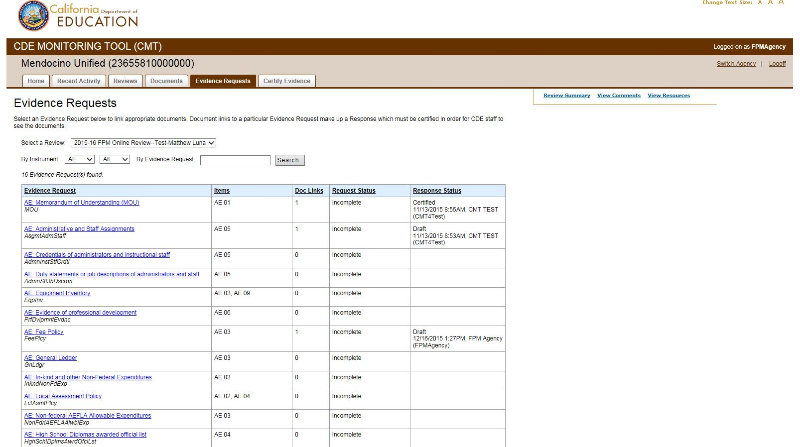

Agency User Management Screen/Users Tab
The “Users” tab is only displayed to users with an agency or user administrator role.
Users with an agency or user administrator role can manage users by adding users and editing user roles.
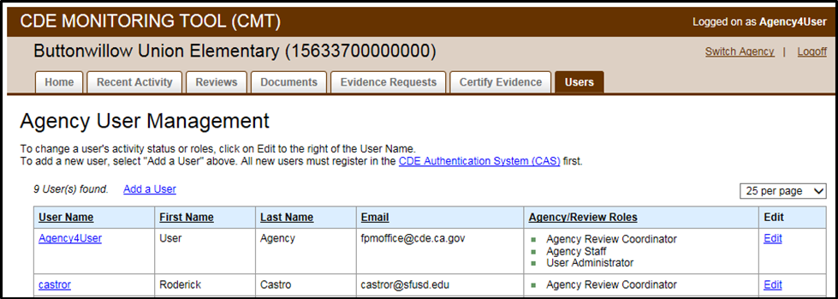
To add a user:
- Select the “Add a User” link in the Agency User Management screen.
- Search for the user’s name in the Agency User Management search form using the field to type the exact User Name (same as in CAS), then select “Search.” An individual must be registered in CAS in order to be added as a user in CMT. The “Agency User Management” screen contains a link to the CAS registration Web page.
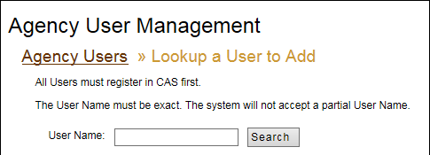
- Select “Confirm User”:
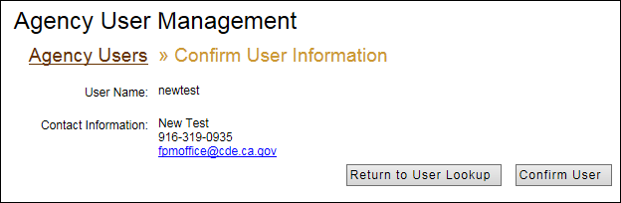

- Select the user name link to assign the user roles:
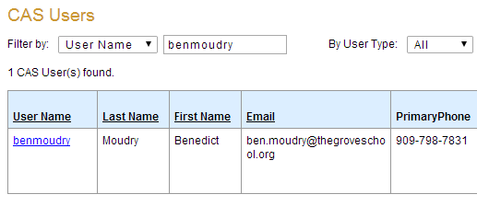
- Assign the user roles:
Agency Roles: Select “Agency Level Access” to provide a user read-only access to all of the agency’s information and reviews in CMT. Once this access is selected, two additional roles can be assigned:
- Agency Administrator: This role can assign additional Agency Administrators and has full access, including user management access, to all of the agency’s reviews in CMT. It is recommended to only have one or two Agency Administrators per agency. This role is initially assigned to the agency’s designated main Federal Program Monitoring (FPM) contact by the FPM office.
- User Administrator: This role can add CAS users to CMT and manage users at the Review level.
Review Roles: Review roles provide a user access to a particular review. These roles can be added to a user’s “Agency Level Access”, or assigned to users without Agency level access.
Select the appropriate review role:
- Agency Review Coordinator: This role allows the user to upload and link documents, certify evidence requests, and post and view comments for all program instruments. This role is initially assigned to the agency’s designated main FPM contact by the FPM office.
- Agency Review Staff: This role is for support staff who only upload and link documents, and post and/or view comments. This role cannot certify evidence requests. The Agency Review Staff user information is not displayed on the review screens in CMT.
- Agency Review Program Staff: This role can upload and link documents, certify evidence requests, and post and view comments for the assigned program instrument(s). The Agency Review Program Staff user information is displayed in the Agency Program Staff column on the “Review Summary” screen in CMT (p. 7).
Select “Save.” Do not select “Inactivate User” without ensuring that the user does not need access to CMT. Many programs use CMT.
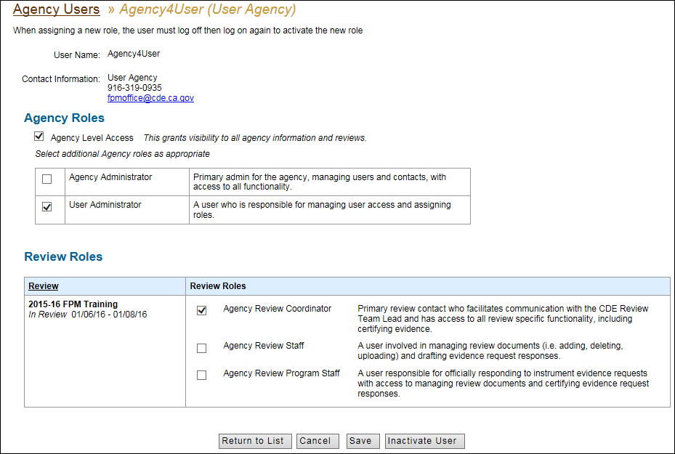
To edit an existing user’s roles:
- On the “Agency User Management” screen under the “Users” tab (p. 11), select the “Edit” link for the user in order to update the user’s roles:
- Follow step 5 on pages 12–13, above.
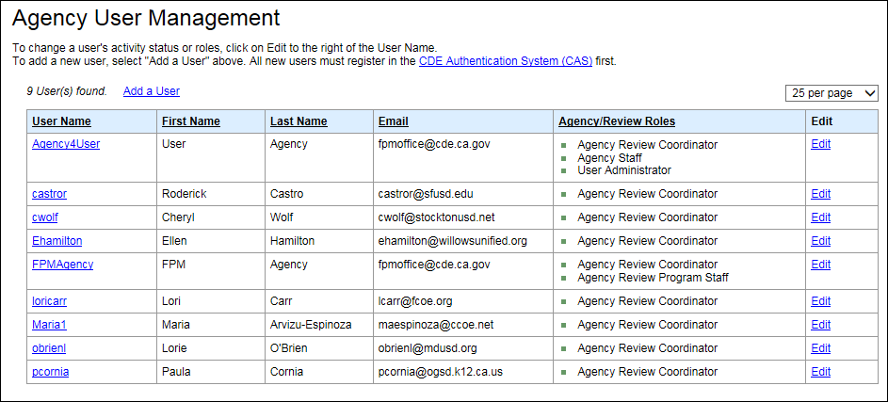

Agency Documents Screen/Documents Tab
Once the user is familiar with the instrument item requirements and evidence requests pertaining to a review, the user will begin uploading required evidence in CMT.
To upload evidence:
Use the “Add a Document” area on the right of the “Agency Documents” screen under the “Documents” tab.
- Enter the “Document Title” and “Description” in the appropriate text boxes. The document title must be unique from other document titles in CMT. The title could include a version number or date. The document description is general, relating to all program instruments relevant to the document.
- Use the “Document Type” drop-down menu to select the type of evidence to be uploaded.
  - If attaching a file from the user’s computer, select “File” as the “Document Type”, then select “Browse” to locate the file and select it.
  - If providing a Web address, select “Web Address” from the “Document Type” drop-down menu, and type the Web address in the text box below the drop-down menu. Web addresses should only be provided when an evidence request requires information that is normally provided via an agencies public Web site. Be sure to indicate full path to the Web page. Posting a Web address for a document located on a web-based file sharing service, such as Google docs, is not acceptable.
  - The “Hard Copy” option is for on-site reviews only and documents that cannot be uploaded to CMT due to sensitive nature or inability to upload.
- Select “Add Document” button.
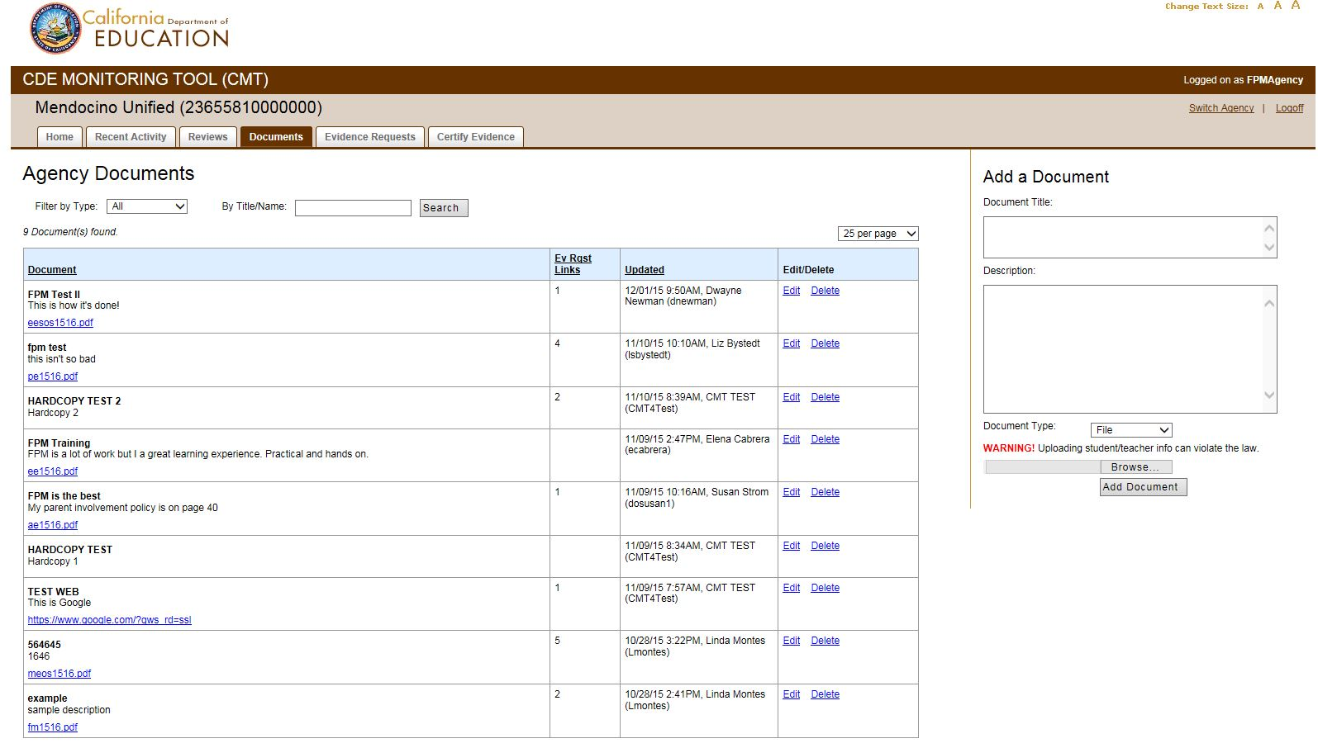
The “Agency Documents” screen displays all documents uploaded by the agency. Columns display information regarding updates made to each document, and options to “Edit” or “Delete” each document, unless it is displayed as “Locked.”
A document appears as “Locked” if a CDE program reviewer has locked a link to the document. Locked documents cannot be edited or deleted, although revised versions of documents can be uploaded in CMT.
In CMT, most column headings can be used to sort the information displayed. Select an underlined column heading in order to sort the list by that topic, e.g., sort by “Updated” date.
To display only certain evidence types from all uploaded evidence, use the “Filter by Type” drop-down menu to filter the list by type. To search for a particular uploaded document, type the document title in the text box and select “Search.”
Each document is uploaded only once, and then it can be linked multiple times to various program instruments’ evidence requests. For instructions on linking documents to evidence requests, see the “Evidence Requests Screen/Tab” section of this manual on page 18.

Posting and Viewing Comments
On various screens, to the right, is a Comments area (as shown in screenshot below).
To post a comment:
- Type in the text box under “Add a Comment.”
- Select the level of the comment from the “Regarding” drop-down menu (see Note below).
- Select the “Add Comment” button.
Note: Be mindful of the contents of the drop-down menu displaying what the comment is regarding. Most agency comments should generally be posted at the evidence request level regarding an evidence request; in the text of the comment, the user can reference a particular instrument item number if commenting on or questioning what is needed for a particular item’s requirements regarding the evidence request.
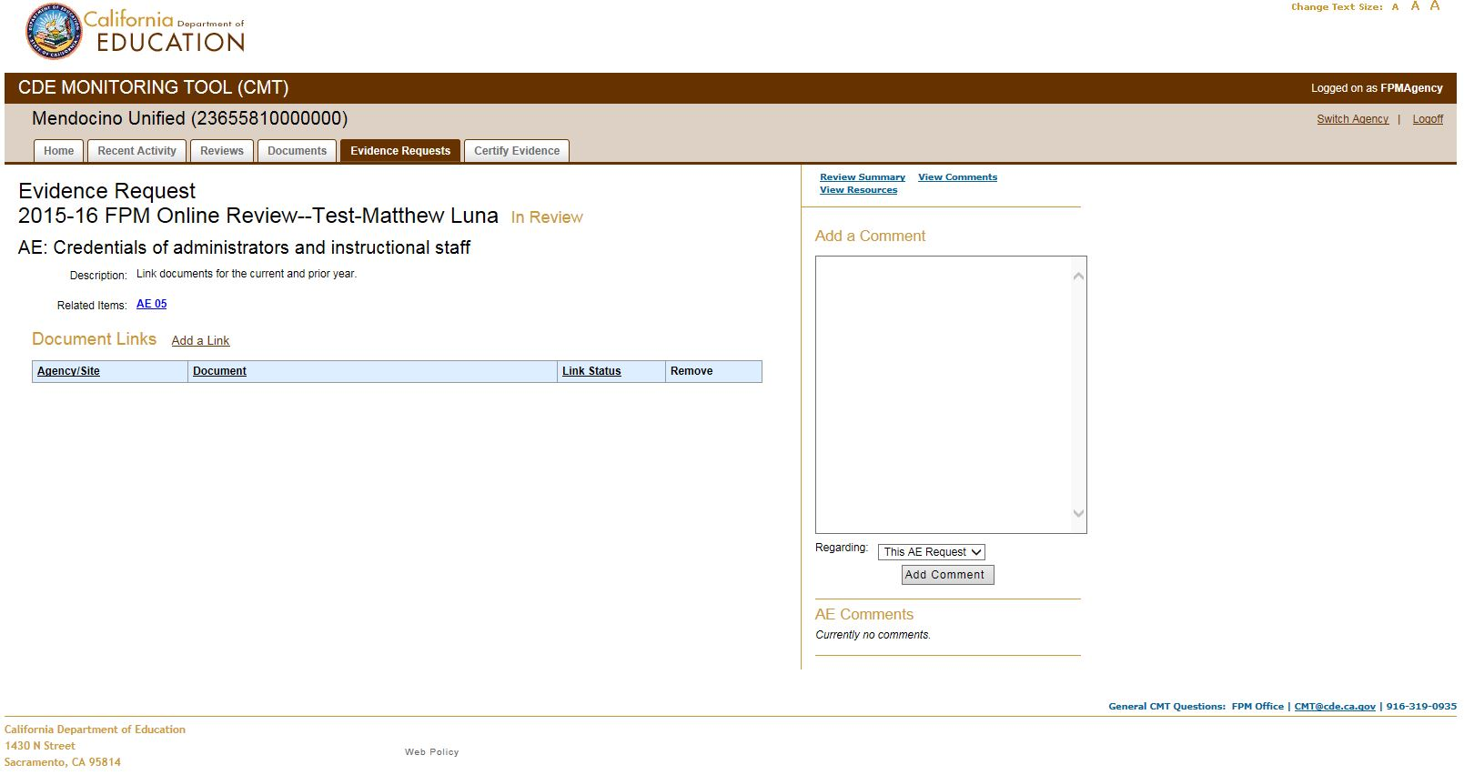
To view all comments, the user can select the “View Comments” link from various screens. This displays the comment thread.
Using comment thread filters:
After selecting the “View Comments” link, be mindful of the filters at the top of the screen. These filters will default to only show certain information based on which screen the user used to navigate to the comment thread. Use the filters at the top of the Comments screen to display all comments for the entire review, for a certain program instrument, for a certain item, etc. If the user filters comments by an instrument item number, all evidence request level comments and item level comments associated with that item will appear in the thread. Keep in mind that one evidence request may be associated with multiple items within one instrument; in this case, comments for this evidence request would be displayed in the threads for all of these items.
The user can select the “Hide My Comments” check box to hide the user’s own comments.
The user can use the drop-down menus to select the number of comments displayed per page, and/or select how the comments are sorted in the display.
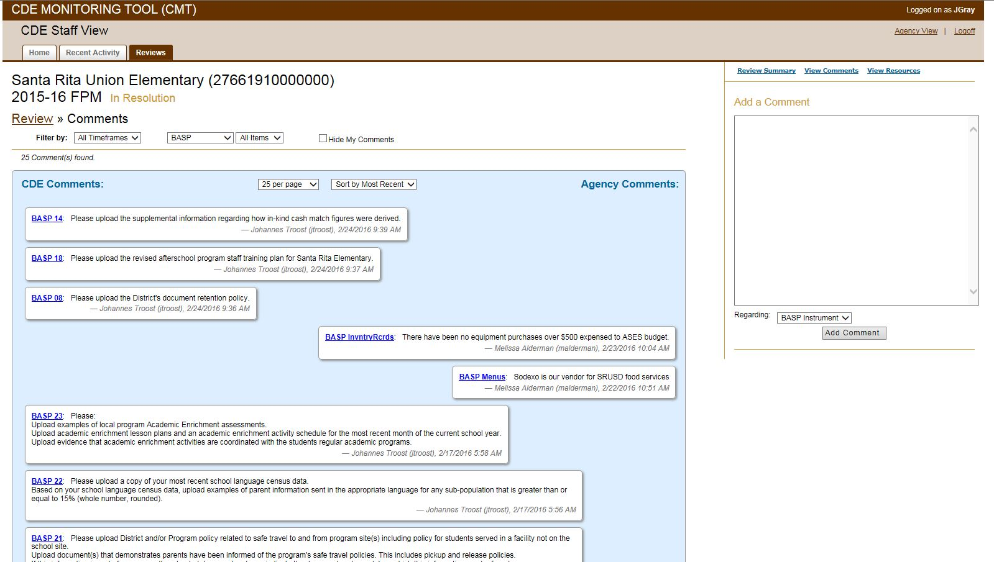

Evidence Requests Screen/Tab
The “Evidence Requests” tab displays the “Evidence Requests” screen. Each program instrument item being monitored is associated with one or more evidence requests to which the agency responds.
This screen lists all evidence requests for the agency. The user can filter the list by review and/or by program instrument. The user can also use the “Search” field to search for a specific evidence request.
The list of evidence requests includes:
- Instrument items associated with each evidence request
- Current number of documents linked to each evidence request
- Status of each evidence request (“Incomplete” or “Currently sufficient”)
- Status of each response (“Draft” or “Certified”)
Document links to a particular evidence request make up a response to the evidence request, which must be certified in order for CDE staff to view the documents.
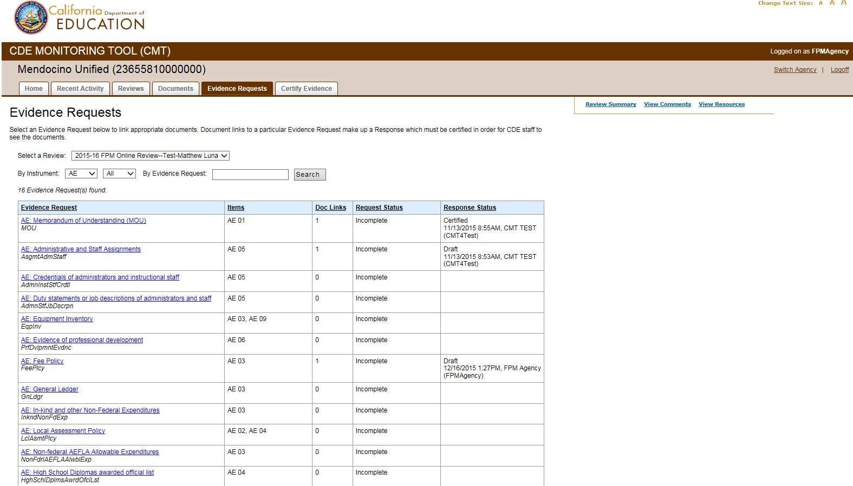
To link documents, select an evidence request to link appropriate documents to that evidence request. The “Evidence Request” screen (below) will then display:
- CDE’s description of the evidence request, explaining in more detail what is required
- Additional, specific instructions about what certain items require (“Item Instructions”)
- All the instrument items related to the particular evidence request from the currently selected instrument (“Related Items”)
  - The instrument item links displayed can be selected and will display the item legal requirements (p. 9)
- Items from other instruments which use the same evidence request
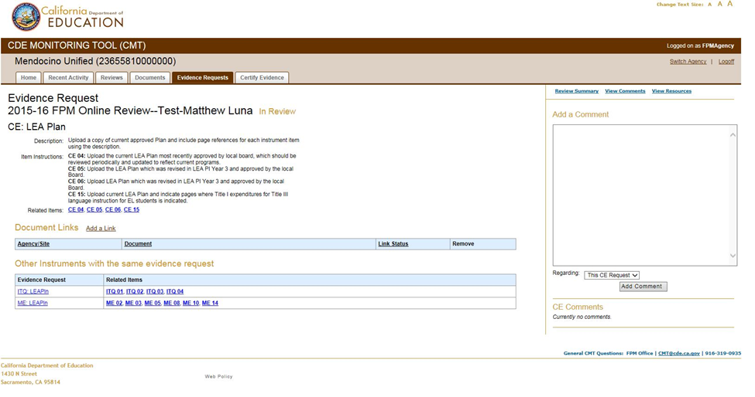
To link an uploaded document to the evidence request for the current instrument, select “Add a Link.” The following screen will then display:
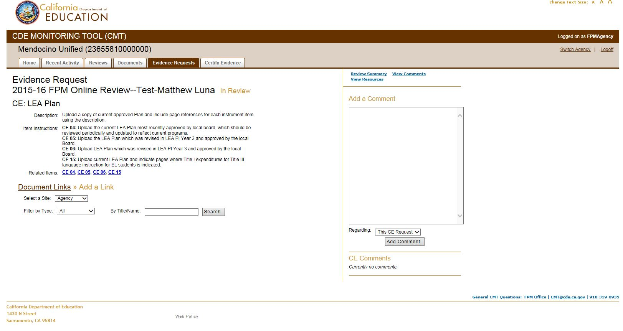
The user can search by type of evidence, or by the title/name of the document the user would like to link to the evidence request. To show all documents, leave the “Search” field unpopulated. Select “Search.” The list of uploaded documents will be displayed as shown in the following screenshot:
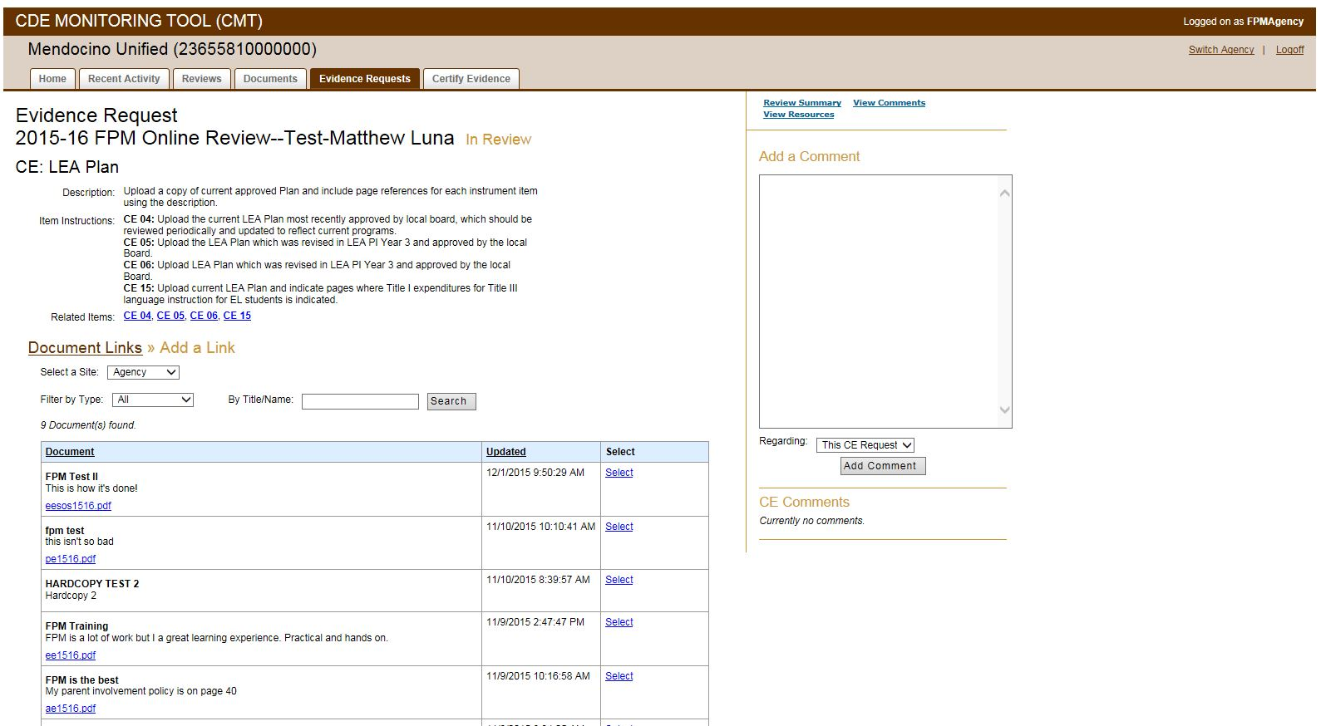
Select the document to link to the evidence request. The user can enter a “Link Description” in the text box as shown in the screen shot below. The “Link Description” contains instrument-specific information, e.g., page numbers in the linked document that contain information for particular program instrument item(s). (“Item Instructions” specify item requirements.) Then, select “Add Link.”
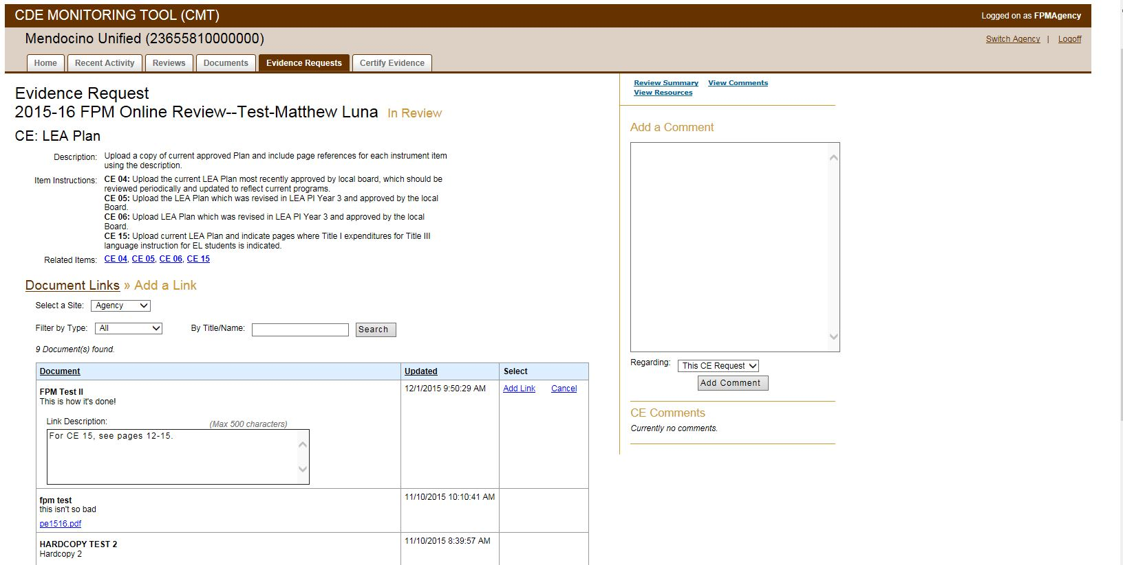
A message reading “Success. Select another document to link or click Document Links to go back to the linked list” will display indicating the document is linked to the evidence request as shown in the following screenshot:
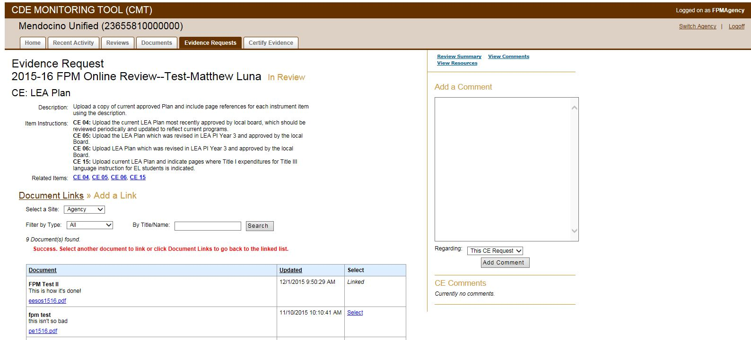
The user can select other documents to link to the evidence request by following the same steps above. Select the “Document Links” link to see all documents linked to the particular evidence request.
When the user links documents to an evidence request for an instrument, all items in that current instrument that use that evidence request will receive the documents. However, the user must manually link documents to the evidence request for each of the other instruments that use the evidence request. Other instruments with the same evidence request are displayed for convenience as shown in the following screenshot:
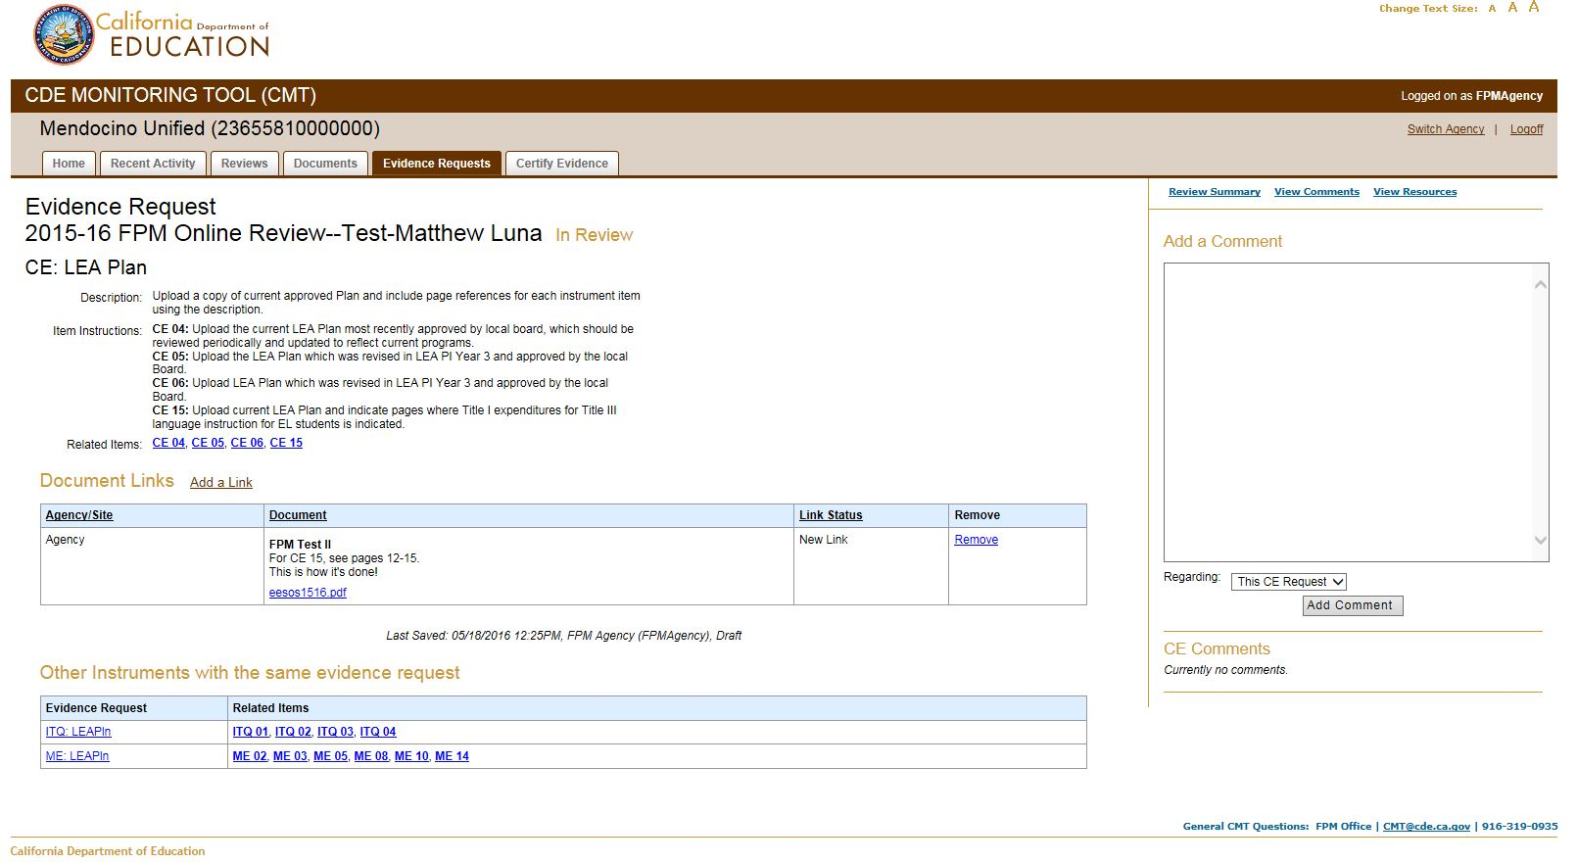
Status of evidence requests and responses:
The status of each evidence request will display as “Incomplete” or “Currently sufficient” (p. 18). The CDE program reviewers update these statuses as the review progresses. “Currently sufficient” indicates that no further documentation is required for that evidence request at that time. “Incomplete” indicates that further evidence may be required for that evidence request. Refer to comments in CMT for information from the reviewers about further evidence required (p. 17).
Document links to a particular evidence request make up the agency’s response to the evidence request. The evidence request response must be certified by the agency in order for CDE staff to view the documents/evidence. The status of each evidence request response will display as “Draft” or “Certified” (p. 19). The date, time, and user information will display. For instructions on how to certify evidence request responses, see the “Certify Evidence Screen/Tab” section (p. 23).

Certify Evidence Screen/Tab
Document links to a particular evidence request make up the agency’s response to the evidence request. The evidence request response must be certified by the agency in order for CDE staff to review the documents. By certifying an evidence request response, the agency is signaling that the evidence is ready to be reviewed.
To certify an evidence request response, the user selects the “Certify Evidence” tab and selects the “Certify” link, as shown in screenshot below.
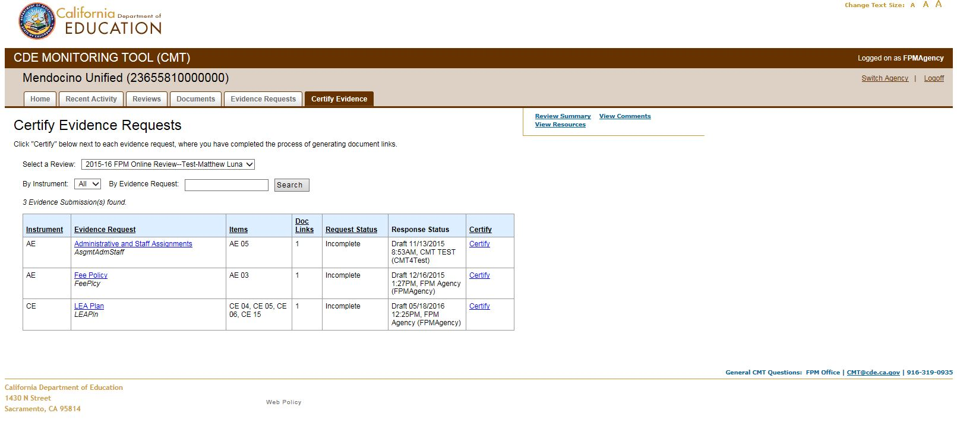
The screen will display a message reading “Success” indicating certification of the evidence request response was successful as shown in the following screenshot:
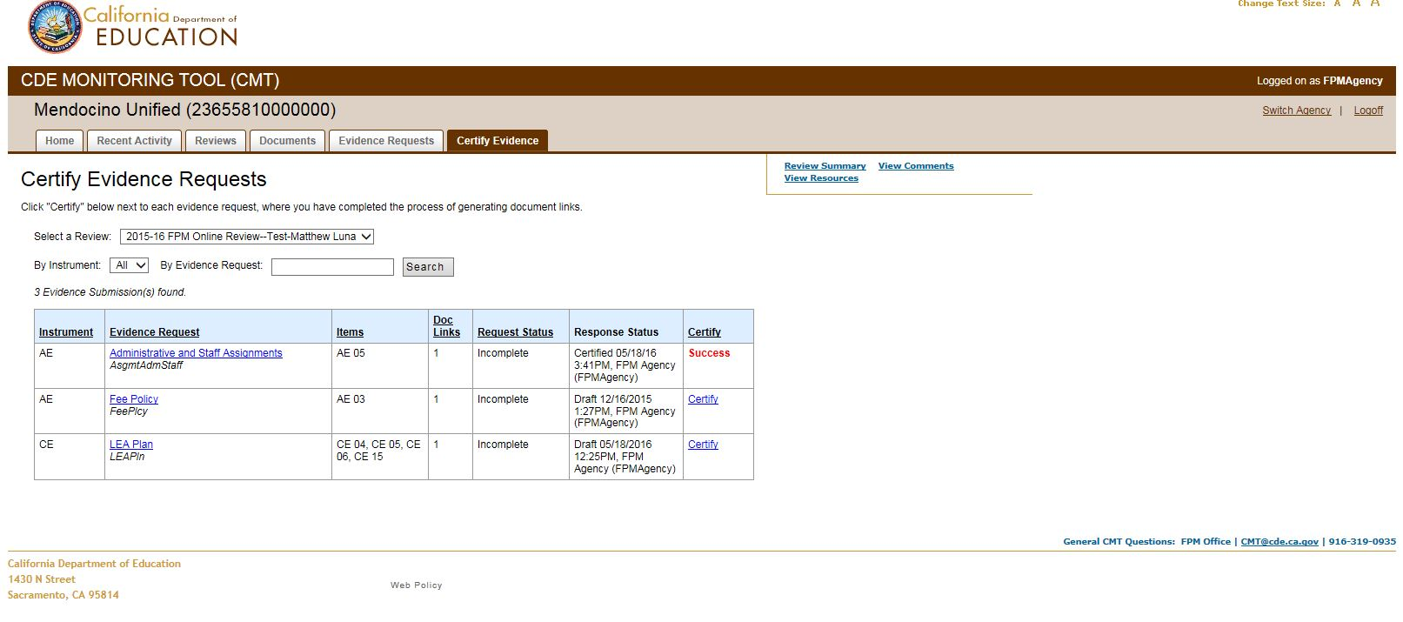
Use the filters and “Search” feature at the top of the screen to find specific evidence requests to certify.
To meet review deadlines for providing required evidence, the agency must upload, link, and certify evidence by the deadline. Agencies should certify evidence request responses as soon as possible, enabling CDE program reviewers to begin reviewing the evidence. After certifying, agencies can continue to add evidence to the evidence request response and certify the evidence request response again.

View Resources
CMT has a “Resources” section to allow the CDE program reviewers to provide agencies with documents such as samples or templates. To access “Resources,” the user can select the “View Resources” link on the top right corner of most CMT screens as shown in following screenshot:
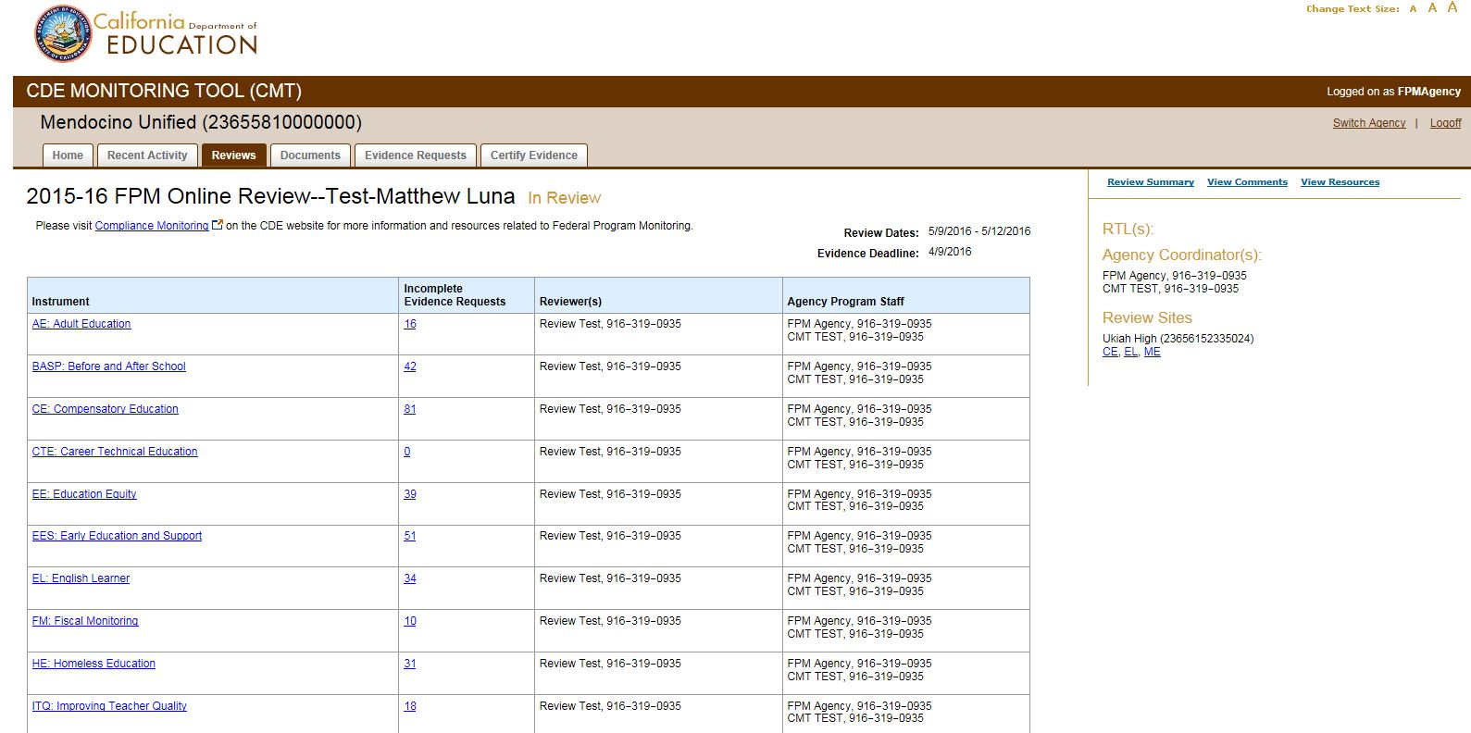
Keep in mind that if the user accesses “Resources” from the link on the “Review Summary” screen, the “Resources” screen will default to displaying all documents for the review. However, if the user accesses “Resources” from the link on an instrument screen, the “Resources” screen will default to displaying all documents provided by the reviewer for that specific instrument. The user can use the filter at the top of the screen, as shown in the following screenshot, to customize the resource documents that are displayed:
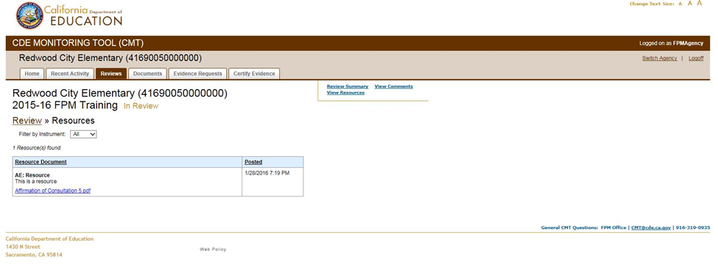
Under “Resources,” you may find a helpful Excel spreadsheet listing all evidence requests for your review. It lists each evidence request including title, abbreviation, description, and related instrument items, in one searchable, sortable document.
After a review, the official Notification of Findings (NOF) report is archived in “Resources” in CMT.

Recent Activity Tab
The user can select the “Recent Activity” tab to monitor activity occurring in CMT by review and by timeframe. Use the drop-down menus to customize the information displayed. The user can select the box to hide his or her own activity in order to only see activity generated from other users.
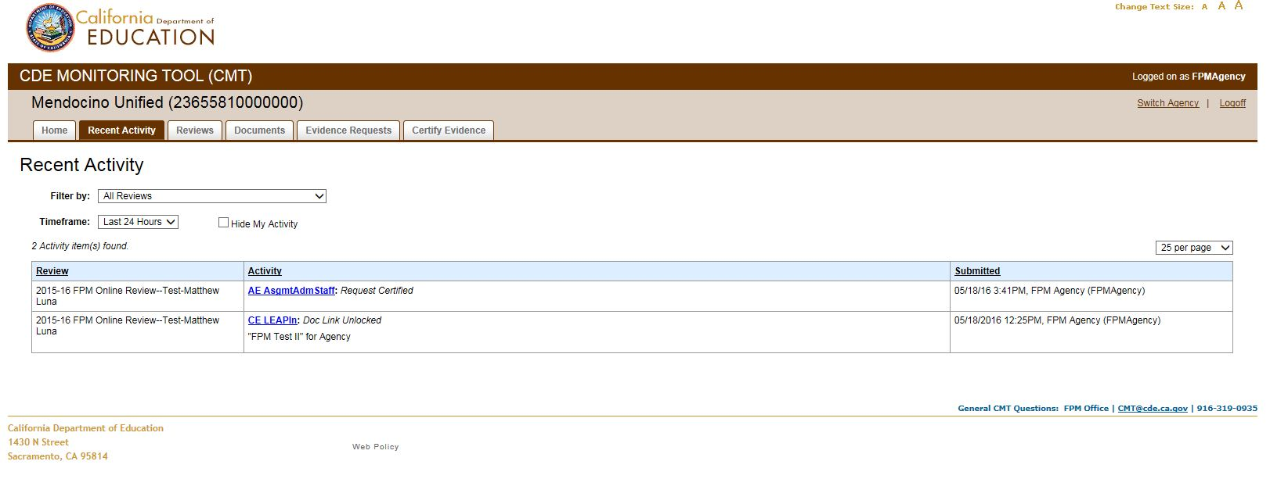

Stages of the Review

Pre-Review
During the “Pre-Review” stage before the review dates, agencies are focused on becoming familiar with the program instruments, item legal requirements, and evidence requests that require responses. Agencies are free to communicate with the Regional Team Lead RTL and program reviewers with any questions as users in CMT upload, link and certify documents as soon as possible and no later than the initial evidence deadline, which is listed in CMT as the “Evidence Deadline.” The Agency Review Coordinator manages the user accounts for agency CMT users involved in the review.

In Review
During dates that fall within the review dates listed in CMT, the agency is considered “In Review.” During this stage, the “Recent Activity” tab may be especially useful to stay apprised of activity when working with deadlines. Communication will be occurring through comments; statuses will likely be changing; and additional required evidence should be uploaded, linked and certified within timelines.

In Resolution
In the resolution stage following the review dates, if there were findings, the “Home” screen will display the number of unresolved findings by program instrument, the number of incomplete evidence requests, and the resolution deadline as shown on page 30.

Complete
The review is considered to be in the “Complete” stage following the review dates when there have been no finding or after all findings have been resolved. Once a review is complete, only users assigned the Agency Administrator role will have access to the review and as read-only.
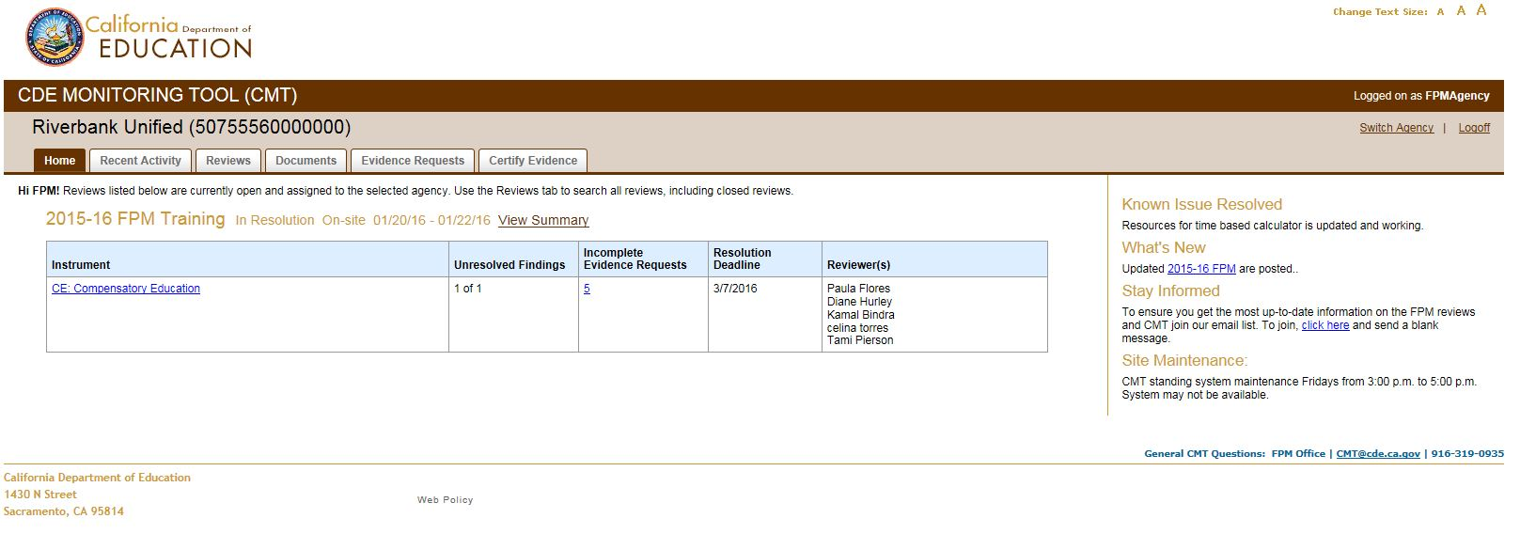
The user can select a program instrument link to display the information in more detail about that specific program’s findings and resolution deadlines by finding as shown in the following screenshot:
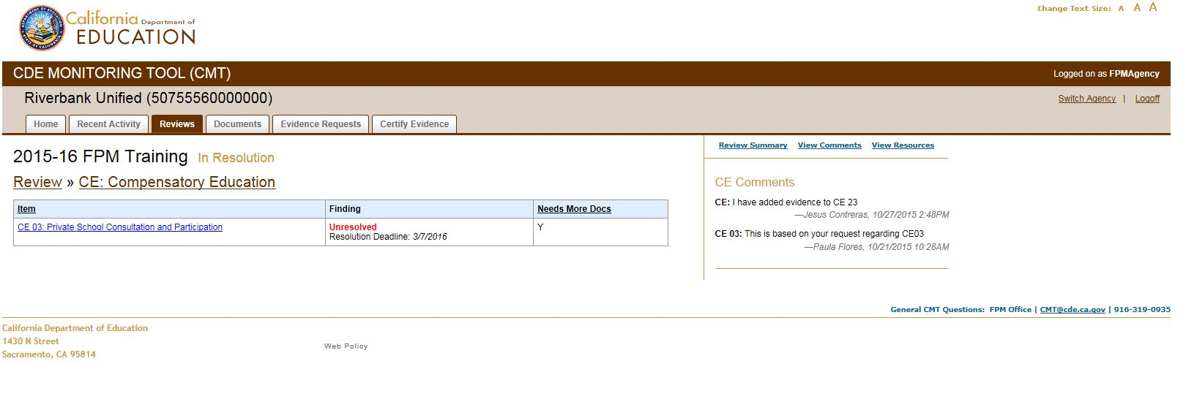
To resolve findings, the agency continues to upload, link, and certify required evidence. The agency also continues to communicate with program reviewers using comments in CMT.
Resolution Agreement Requests
All findings are to be resolved within 45 calendar days after the review. This date appears on the findings report and in CMT. However, if a finding cannot be resolved by the 45-day due date, the user does the following in CMT to request a resolution agreement:
Post a comment at the item level, or a comment indicating the item number, with the following information:
- Extended due date requested (specific date)
- Justification for extension (brief explanation)
- Activities you will complete between now and the extended date in order to resolve the finding
The program reviewer will respond by approving or denying the request. If approved, the reviewer will change the due date in CMT for that item. The updated due date will appear in CMT.

Glossary
Active Review: Reviews that are in the pre-review, in review, and in resolution stages.
Agency: Any entity that receives certain state and/or federal funding, including local educational agencies (LEAs) and other recipients of such funds.
Agency Administrator: CMT agency role that allows the user to assign additional Agency Administrators and has full access, including user management access, to all of the agency’s reviews in CMT.
Agency Review Coordinator: CMT review role that allows the user to upload and link documents, certify evidence requests, and post and view comments for all program instruments.
Agency Review Program Staff: CMT review role assigned to users that allow the user to upload and link documents, certify evidence requests, and post and view comments for the assigned program instrument(s).
Agency Review Staff: CMT review role assigned to support staff who only upload and link documents, and post and/or view comments.
Bulletin Board: The Home screen contains a bulletin board with FPM monitoring content relevant to agency staff.
CAS: Users use the Centralized Authentication System to maintain their accounts with which they access CMT.
Certify: The LEA selects “Certify” to officially submit evidence for review by the reviewer. The reviewer can only view certified evidence in CMT. The term certify does not imply finality; the LEA may certify as many times as needed.
Comments: Posting comments is the function in CMT used for communication purposes.
Complete (Review Stage): Term used for the review stage following the review dates when there are no findings or after all findings have been resolved.
CMT: CDE Monitoring Tool, an online communication and management tool that supports the FPM process.
Evidence request: Guidance provided by programs to assist LEAs in selecting documents to demonstrate legal compliance. An instrument item can be associated with multiple evidence requests. In addition, one evidence request can be associated with multiple items.
Findings: Items not in compliance with minimum legal requirements based on a review of the evidence provided by the LEA.
In Resolution (Review Stage): Term used for the review stage following the review dates when there are findings that are not yet resolved.
In Review (Review Stage): Term used for review stage during the review dates.
Inactive Review: Reviews that are in Complete review stage.
Item Instructions: Program instrument item specific instructions for an evidence request.
Link: The term used in CMT for the connecting element between documents and evidence requests.
Link Description: A text box displayed when linking a document to an evidence request response where a user can enter item-specific information including information requested in an item instruction.
Locked Documents: A document appears as “Locked” if a CDE program reviewer has locked a link to the document. Locked documents cannot be edited or deleted, although revised versions of documents can be uploaded in CMT.
Notification of Findings: Official report of findings of non-compliance with requirements found during either the online or on-site monitoring review.
Online: Characterizes an FPM review, or portion thereof, conducted only through the CMT.
On-site: Characterizes FPM team visit to an LEA and selected schools and programs for monitoring.
Open Review: Reviews that are in the pre-review stage, in review stage, or in the resolution stage with findings remaining to be resolved.
Pre-review (Review Stage): Term used for review stage before the review start date.
Program Instrument: The FPM Instrument for each categorical program contains federal and state legal requirements organized into statutory core items and supporting items arranged under seven general CDE dimensions. FPM team members use Program Instruments to determine whether an LEA is meeting requirements of each item.
Program reviewers: CDE staff, on FPM teams, who monitor programs using their program instruments.
Recent Activity: Activity occurring in CMT by review and by timeframe.
Resolution: Process to bring the LEA into compliance following a review which has findings.
Resolution Agreement: An agreement between the agency and the program reviewer on an extension date beyond the initial 45-day due date for resolving findings.
Review Roles: Review roles provide a user access to a particular review. These roles can be added to a user’s Agency level access, or assigned to users without Agency level access.
Review Site: Specific sites selected for review in the monitoring process.
User Administrator: CMT agency role that allows the user to add CAS users to CMT and manage users at the Review level.

